Basic layout without classrooms for High school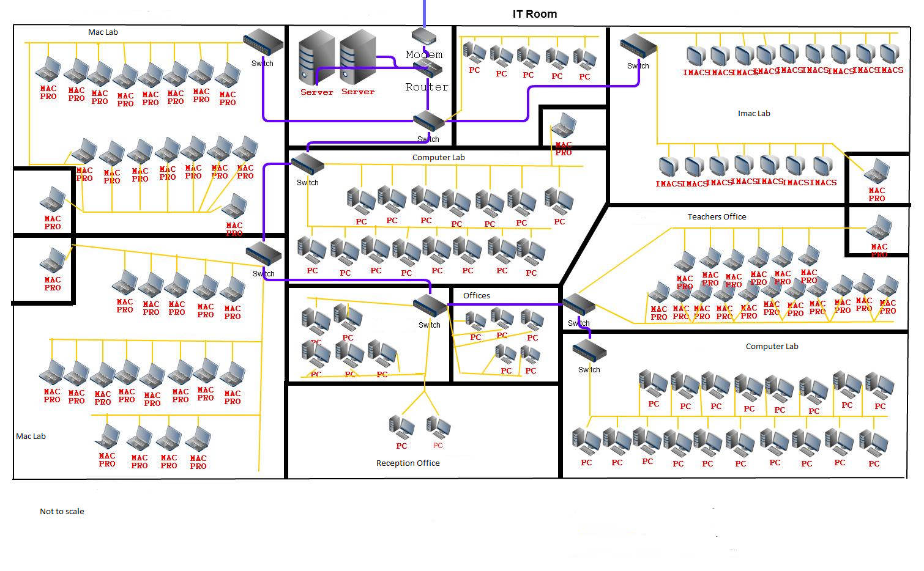

Black and White Printer

<http://www.brother-usa.com/MFC/ModelDetail/4/MFC7240/Overview#.VGeEFPnF_p4>

Color Printer

<http://www.brother-usa.com/MFC/ModelDetail/4/MFC9130CW/Overview#.VGeED_nF_p4>

Desktop

<http://www.samsclub.com/sams/hp-110-210-pc-amd-a4-5000/prod13210078.ip>

Cameras

http://www.lorextechnology.com/Security-cameras-for-home-and-business/Security-surveillance-cameras-4-pack-with-night-vision/2187.p

Imacs

